FIELD REPORT

Introduction
- Tekulu HC III
- Location: Omoro district
- Date of visit: 1st September 2026
General observation
- The verification exercise was conducted with the support of the available health officers. However, some of the equipment could not be easily identified because the officers were not familiar with the specific names or technical descriptions of certain items. This made the verification process more complex, particularly when matching the physical assets against the available documentation.
- The maternity ward is currently under construction, which has significantly reduced the facility’s available space for service delivery. The ongoing construction works have required the facility to operate from limited space, creating congestion and affecting the efficient organization of services.
- The maternity services are currently being provided from a temporary space that was originally intended to function as a laboratory. As a result, the laboratory space is not being used for its intended purpose, potentially limiting the facility’s capacity to provide laboratory services effectively.
- The facility reported that the building currently being used for maternity services requires renovation to make it suitable for its temporary function. However, the necessary renovation works have not yet been undertaken.
Special notes
- The ongoing maternity ward construction should be closely monitored to ensure timely completion and commissioning. Prolonged construction may continue to constrain the facility’s operational space and affect service delivery.
- The use of the laboratory space for maternity services is a temporary arrangement and may compromise the availability and functionality of laboratory services if it continues for an extended period.
- The difficulty in identifying some equipment indicates a need for clearer asset descriptions and/or technical specifications in the relevant delivery and asset documentation. This would support easier identification and verification by facility staff.
- Facility staff may also require orientation on the names, functions, and identification of specialized equipment provided under the program to strengthen asset management and accountability.

MATERNITY BLOCK | 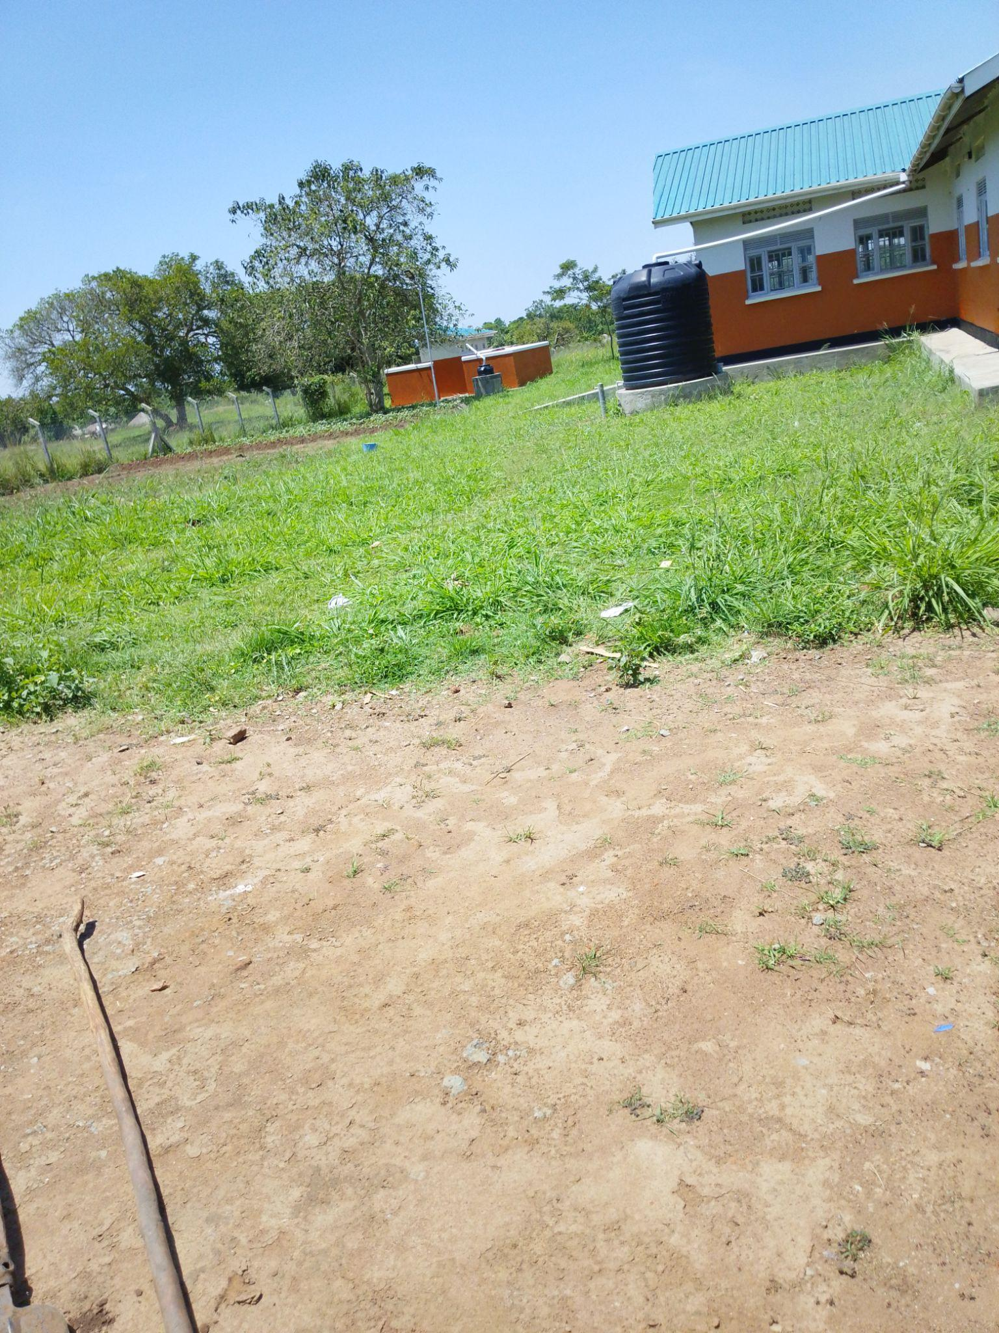
TYPICAL SET OF STAFF HOUSING (TWO UNITS AND TOILET BLOCK WITH A WATER TANK) | 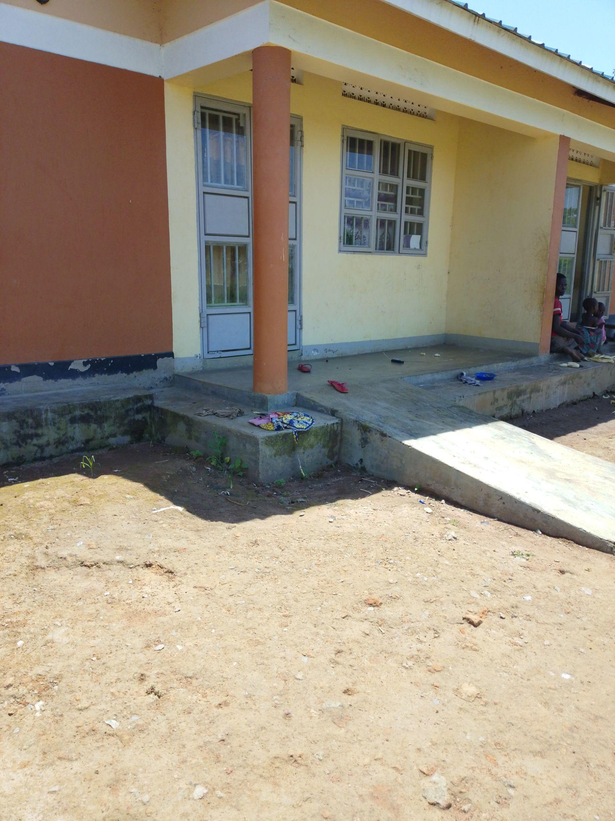
TYPICAL SET OF STAFF TOILETS (2 STANZAS PER UNIT) | 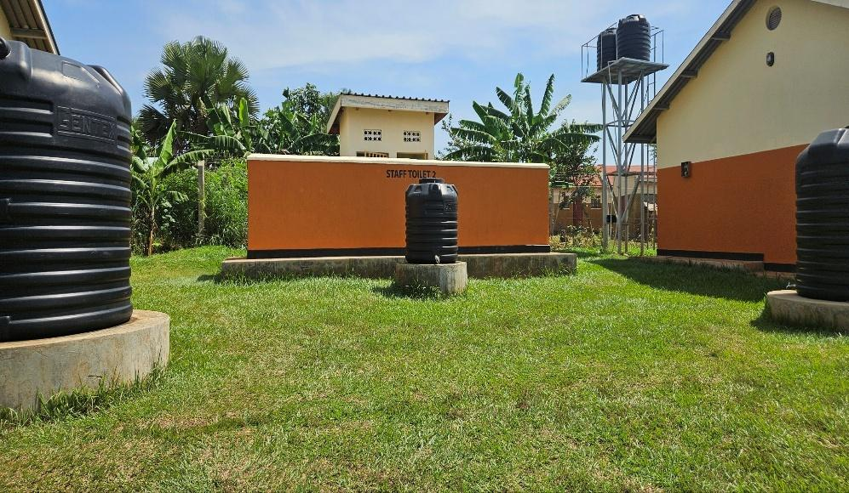

MATERNITY BLOCK (Houses the labor suite, post-natal, inpatient and stores room)

